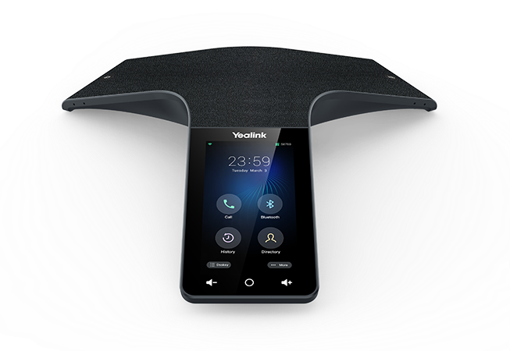 | Yealink® CP965 Conference Phone  The Yealink® CP965 is a color, touch screen conference phone featuring superior audio performance with optional wireless MICs. This guide is designed to help you use some of the most popular features with your new Yealink® CP965 phone.

Icons  The icons located on the touch screen perform the functions that appear below the icon.  Line Keys  With the CP965, you can access up to 30 total virtual keys. The line keys are found by swiping right on the main display. These keys indicate the status of your monitored lines and associated activity. The icons inform you when a line is idle, ringing, in use or on hold. If you have more than 6 BLFs assigned, touch the number on the tabs to go to that page of BLFs.  Navigation Keys  Navigation is performed by touching any on-screen icon, then using you finger to scroll up or down through any lists. To select an item, touch any entry in the list or touch an icon. The Circle icon below the display between the volume controls can be used to return to the main screen at any time.  Answer a Call  To answer a call, simply touch the Answer icon. Touch the Reject icon to send the call to voicemail.  Place a Call  To place a call, touch Dial, then dial the number. Calls can also be placed by choosing a number from the Contacts or History icons along the top bar on the dial screen. Touch the icon, then scroll until you find the entry you want and select it to dial the number. |  | Feature Codes  *72 Call Forwarding Always Activation  *73 Call Forwarding Always Deactivation  *90 Call Forwarding Busy Activation  *91 Call Forwarding Busy Deactivation  *92 Call Forwarding No Answer Activation  *93 Call Forwarding No Answer Deactivation *44 Call Recording (if enabled)  *67 Calling Line ID Delivery Blocking per Call *65 Calling Line ID Delivery per Call  *68 Call Park  *88 Call Park Retrieve  *98 Call Pickup  *11 Call Retrieve  *69 Call Return  *70 Cancel Call Waiting  *99 Clear Voice Message Waiting Indicator  *55 Direct Voicemail Transfer  *78 Do Not Disturb Activation  *79 Do Not Disturb Deactivation  *62 Voice Portal Access  *66 Last Number Redial  Note: Some of these codes may not be available to all users. See your group admin to add features.

Other Features  Set up Voicemail  - Dial *62 or your extension and place a call.  - At the prompt, enter in a unique passcode, then press #.  - Re-enter your passcode, then press #.  - Follow instructions to record your name.  - Follow prompts to:  - Access voice mailbox  - Access greetings menu  - Change passcode  - Exit voice portal  Retrieve Voicemail Messages  The display will alert you when you have a new voicemail message.  - To check your voicemail, touch the Message icon.  - Touch View Voice Mail.  - Touch the text in the first row for your main line.  - The call is placed to your voicemail box.  - Alternatively, touch Dial, then dial *62 or your extension and do the following:  - Enter your voicemail passcode if prompted, then press #. (If you forgot your passcode, please contact your system administrator.)  - Follow the audio prompts.  Hold and Resume a Call  - To hold a call, touch the More icon, then choose Hold.  - To resume, touch the Resume icon.  Access Call Lists  - Call History can be accessed by touching the History icon.  - Touch Network Calls to expand the call filters, then touch whether to view Network Calls or the subset of Placed Calls, Missed Calls or Received Calls.  - To view information about the call, touch the “i” icon to the right of the entry.  - To dial a number, scroll to the desired entry, then touch the entry. | Do Not Disturb  - To enable Do Not Disturb, touch the Settings icon, then Call Control, then touch Do Not Disturb from the list. Touch the first row and then move the DND Status slider to enabled, then touch the check mark in the upper right corner.  - To disable, navigate through the menus again and change the slider to off, then touch the check mark to save the changes.  Make a Three-way Call  After the first call is connected:  - Touch the + Invite in the center of the screen.  - Dial the new party or touch the Contacts or History icon along the top row and scroll until you find the entry you want. Select it to dial the number.  - When the call connects, touch the Merge Calls button to join the calls.  Transfer a Call  - After the first call is connected:  - Touch the More icon, then choose Transfer. (The active call will be placed on hold.)  - To transfer the call unannounced, enter the number and touch the Transfer button at the bottom. Choose Transfer from the menu to do a blind transfer.  - To speak to the transfer-to party first, Dial the number or extension and touch Transfer at the bottom. Choose Send from the menu.  - When the party answers, announce the transfer. Then touch Transfer again to complete the transfer. Touching End Call disconnects the call to the transferred party. Touch Resume to resume the call with the original party.  To transfer the call directly to another user’s voicemail  - During the transfer process, Dial *55 instead of the extension  - Dial the extension, followed by #.  - A confirmation will announce the transfer is complete.

Call Forwarding
- Touch the Settings icon.
- Touch Call Control from the list.
- Touch Call Forward from the list.
- Choose from Always Forward, Busy Forward or No Answer Forward and touch that entry.
- Use the touch screen to enable options by moving the slider to On.
- Touch each field and enter information, such as the Forward to number using the on-screen keyboard, then touch the check mark icon at the top right of the screen to save your settings.
- To disable, follow the same steps and move the slider to the Off position to set the call forward option off, then touch the check mark icon to save your settings.
Shortcuts
- Pick up handset and dial:
  - *72 = Call Forwarding Always
  - *90 = Call Forwarding Busy
  - *92 = Call Forwarding No Answer
  - Enter destination number, then press #.
- To deactivate, dial:
  - *73 = Call Forwarding Always
  - *91 = Call Forwarding Busy
  - *93 = Call Forwarding No Answer

View a complete user guide at
https://support.yealink.com

